Full stack development
Full stack development is the process of developing both the frontend and backend of applications. Any application has a frontend (user-facing) component and a backend (database and logic) component.
Frontend
Front-end development is the development of visual and interactive elements of a website that users interact with directly. It's a combination of HTML, CSS and JavaScript, where HTML provides the structure, CSS the styling and layout, and JavaScript the dynamic behaviour and interactivity
Backend
The backend is the server side of the website. It manages data and ensures everything on the frontend works properly.
Server: It is a virtual Machine which is built in cloud
How we can go to server ?
Medium+ address
IP Address:
- the unique identifying number assigned to every device connected to the internet.
- Attackers can easily attack
- Instead of IP Address we use texts we can purchase text it is also called as Domain or DNS Server
Eg: godaddy.com

Application: set of programming Languages.
Types of Applications:
Standalone Application:
a type of software program that is designed to run on a single computer or local machine of the user, without the need for a server or internet connection.
web application:
A web application is software that runs in your web browser
Mobile Applications:
Applications designed for mobile devices like phones and tablets
Desktop Applications:
Software installed and run on a desktop

Cloud:
a term used to describe a global network of servers, each with a unique function.
Eg: AWS, google cloud.

Libraries:
Collecting the pre-defined code which is reuse
Framework:
Collection of predefined Libraries is known as Framework.
Eg: React, Dijango & Spring boot.

API
API stands for Application Programming Interface
The working of an API can be clearly explained with a few simple steps. Think of a client-server architecture where the client sends the request via a medium to the server and receives the response through the same medium.
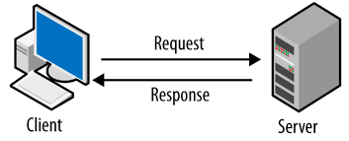
client-server model:
The client-server model, or client-server architecture, is a distributed application framework dividing tasks between servers and clients
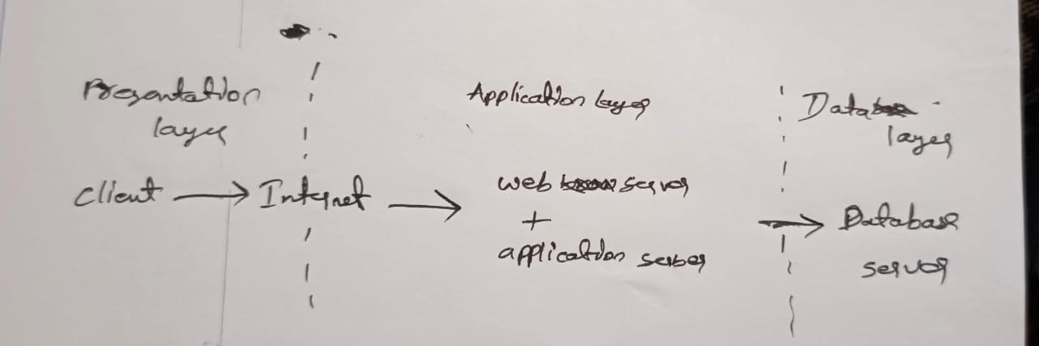

Presentation layer: handles the user interface (UI) part of the web application.
Application layer: also known as the logic tier or middle tier, is the heart of the application. It processes user input, manipulates data, and executes business rules.
Database Layer: where the information that is processed by the application is stored and managed. This can be a relational database management system such as PostgreSQL, MySQL

